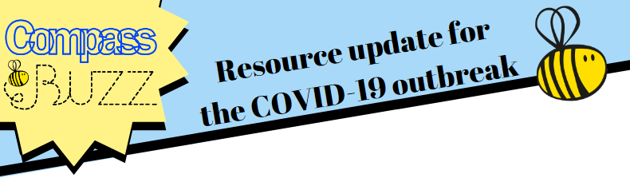
Hi all!
It is Mental Health Awareness Week!
Below are some lovely resources to use with your families that may help you take some time out to think about how we can make sure we are looking after not only our own Mental Health, but also show awareness of other people’s Mental Health too.
A few of these resources are:
- A kindness calendar
- Some kindness challenges
- Reasons to be kind
And many more! Please don’t forget to send any activities you decide to complete to either your class teacher or Miss Thorpe.
To open the documents, right click, click document object, click open and it should open as a PDF.

Friday 15th May 2020
Please see below this week’s free resources that centre on the upcoming ‘Mental Health Awareness Week’ which this year is focused on the theme of kindness. The resources below can be shared with colleagues in your school and also with parents and carers where you feel appropriate.
Why?
Firstly, lets address- why kindness? What are the benefits and why is it this year’s theme for Mental Health Awareness Week? Acts of kindness can be small, but they can have a big impact! Take a look here at some of the benefits.
Acts of Kindness
One of the Five Ways to Wellbeing is ‘Give’; and research has shown that we can improve our own wellbeing by doing nice things for other people, whether that be giving our time, our words or our presence. This resource has some ideas for acts of kindness to try and complete. You can cross them off or cut them out as cards to shuffle and pick from each day.
One act of kindness to focus on could be letting others know how much you appreciate them. This can mean a great deal to people, and often, we might assume they know, but it is really nice to actually hear it or read it! Here is a template for writing a gratitude letter which could be a lovely way to be kind to a friend, relative or member of staff.
Compliments
Another act of kindness to focus on could be complimenting others and letting them know what you like about them. This can be like a gift! Often we might think about gifts as material, physical things like presents. But we can also give people other types of gifts, for example saying something nice and meaningful about them. They might remember this for a long time. These little tear of strips can be nice to anonymously pop on someone’s desk, on top of their bag or perhaps stuck on a bathroom mirror and give them a smile. You can also think about creating your own on little post its that might be more personalised e.g. ‘I love the way you stick up for what you believe in’, ‘you are a good friend because you always ask me if I want to play’ or ‘you are so good at baking, your brownies are the best I have ever had!’. Spread kindness around like confetti!
Self Kindness
Additionally, we want to also focus on acts of self kindness. Sometimes we are so busy being kind to others that we forget to be kind to ourselves, but this is very important for our self-esteem and should not be forgotten! Again, the acts of self kindness can either be crossed out as they are completed, or they can be cut out as cards to shuffle through and select from.
Here is another resource centred on self-kindness, this time around complimenting yourself. We can often have quite a critical inner voice and might pay more attention to our perceived ‘negative’ aspects or traits, or things we do wrong. This can end up giving quite an unbalanced view of ourselves and so we can make a purposeful effort to counteract this by focusing on what we are good at or elements about ourselves that we like. If you can, try to encourage children to think more about compliments that relate to their traits or abilities, rather than physical aspects, though of course those can be included too. This exercise can be useful in building self-esteem.
Another way to encourage self kindness and building of self-esteem is the use of positive affirmations. These are like statements or internal mantras that we can say to ourselves every day to replace negative thoughts for a kinder one.
Five Ways to Wellbeing KIND Challenge
We love the Five Ways to Wellbeing because it is evidence based and also because it is quite flexible and you can use it in lots of different ways. This resource challenges us to do the 5 Ways to Wellbeing but through the lens of kindness, perhaps taking a different approach to each way compared to normal.
Kindness Calendar
At Compass BUZZ we are big fans of the Action for Happiness Calendars, which you can view here https://www.actionforhappiness.org/calendars. They do different themes each month (Kindness was their December edition), and every day there is a prompt for you to do something that ultimately can help you and/or others to feel good. Compass BUZZ have also created a blank kindness calendar for people to add in their own good deeds on, to help keep track of all of their kind actions as they build up. Seeing them build over time will bring a great sense of purpose, satisfaction and pride, which will help improve self-esteem.
Kindness Tree
In life, our minds often focus on the negatives, known as the negativity bias. Our brains have evolved this way over time and it means we can often end up dwelling on the negative aspects of things. This resource is a nice one for reframing and focusing on the positives, paying attention to and noticing the acts of kindness of those around us and perhaps being more appreciative. You can just write your observations onto the tree, or if you have a little more time you could cut out leaves and stick them on with your acts of kindness on.
Whole School Approach to Kindness
The Compass BUZZ Level 1 training examines the 8 principles for taking a whole school approach to mental health and wellbeing which are set out in ‘Promoting Children and Young People’s Emotional Health and Wellbeing: A Whole School and College Approach’ by Public Health England and The Children and Young People’s Mental Health Coalition (2015). In this resource below, we have looked at the 8 principles and taking a whole school approach through the lens of kindness. Includes are some ideas on how to create a culture around kindness.
Resilience Framework
The Resilience Framework is another comprehensive and adaptable resource to use. There are many ways you can use the framework to link in with being kind. The below document highlights some of the ways the framework might be used to link to kindness or self kindness.

