dream, believe, aspire, achieve

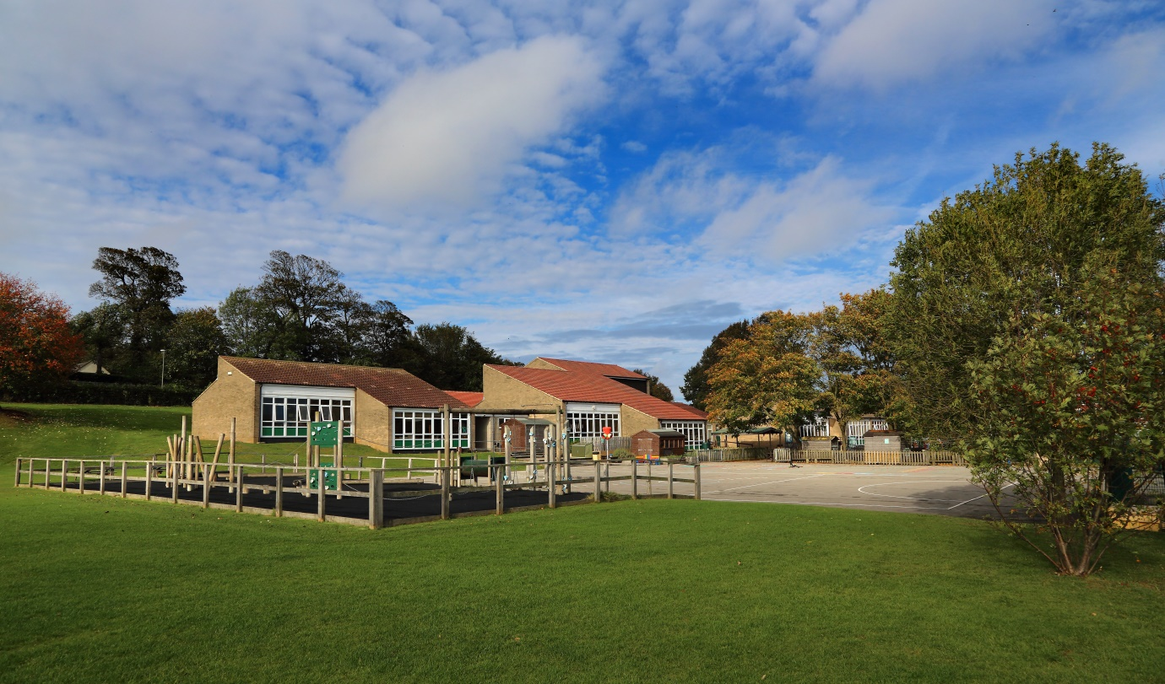

Airy Hill Primary School
Recruitment Information Pack

Midday Supervisory Assistant
6.25 hours per week, term time only

Welcome from the Headteacher

Dear Applicant,

Allow me to extend a warm welcome from all governors, staff and children at Airy Hill Primary School. I am so pleased you have shown interest in joining us and I look forward to sharing with you, details about our wonderful school.

I am very proud of our school in which pupils succeed and flourish. They achieve well across the whole curriculum. We have a very strong school community where staff care for our pupils and their well-being. Children’s behaviour is excellent throughout our school and reflects our high expectations. Not only do pupils behave very well, but they look out for one another and are helpful, polite and welcoming to visitors. Children are keen to talk about how much they enjoy their learning. They feel safe and know that there are adults that they can talk to if they have concerns. Our school values run deeply through the life of our school and are easily identified by anyone visiting us. Relationships between adults, children and our wider community are excellent. Children learn about their local heritage as well as aspects of culture from around the globe - they value and celebrate the differences in each other.

Any new post in our school is an important part of our journey and we look for colleagues who share our ethos and values, understands our context and can provide the inspiration our children thrive on and deserve.

The school is part of the Yorkshire Endeavour Academy Trust. We are also a strategic partner in the Esk Valley Teaching Schools Alliance and work closely with the English Hub. As such, we provide all our staff with substantial, high quality CPD throughout each year.

I look forward to reading your application.

Catherine Matthewman
Headteacher

Dream, Believe, Aspire, Achieve
Airy Hill Primary School’s vision is to develop enthusiastic and ambitious citizens of the future equipped with the knowledge, skills and understanding to achieve their true potential.
Airy Hill’s Mission 2019-2021
Ambitious teaching and learning is delivered to ensure that every child meets their true potential
Independent learning skills are developed and promoted throughout the school
Reading is at the centre of all learning at school and at home
Young children are developed into positive, conscientious citizens with thoughtful behaviour and attitudes

Have a zero-tolerance approach to poor school attendance
Involve the community in extending a broad and balanced curriculum that excites children
Link the skills of fluency, reasoning and problem solving to create efficient mathematicians
Let children experience success and failure to create resilient individuals

What can Airy Hill Primary School offer you?
- Amazing children who will make you smile EVERY DAY!
- Outstanding School Leadership
- High quality CPD with opportunity to learn from the best locally and Nationally
- Opportunities to work with colleagues from across the Yorkshire Endeavour Academy Trust
- A friendly, welcoming and supportive staff team
- A thorough induction
- Dedicated school governors

How well do children at Airy Hill Primary School

In 2019, the school’s results increased in a number of key areas from 2017 and 2018. As a school we feel incredibly proud of the improvements we have seen and of the hard work of children and staff alike.
You can read the official information about our school by following the link below but here are our data headlines:
Early Years
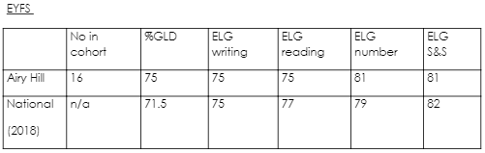
Phonics Screening Check
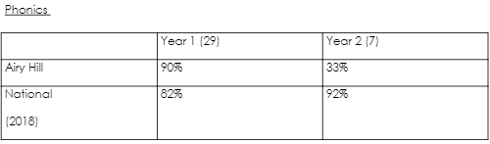
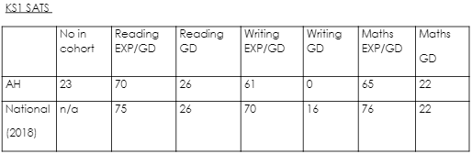
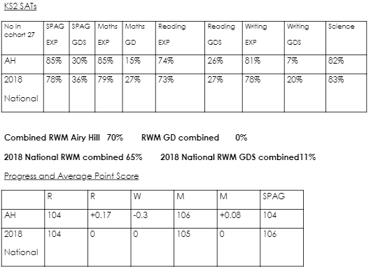

Where can you find more information about us?

Website: airyhill.n-yorks.sch.uk
Trust Website: yeat.co.uk
Facebook: facebook.com/Airyhillprimaryschool
Ofsted: reports.ofsted.gov.uk/provider/21/144679

Application Process

The closing date for applications is: Friday 13th November 2020

Interviews will be held on: The following week

Completed application forms should be returned to: admin.airyhill@yeat.co.uk

If you think you’re the person for the job, please complete the attached application form to the email address above, by the closing date.

An email will be sent to shortlisted candidates with details of the interview process. If you have not heard from us within a week of the closing date, please assume your application has been unsuccessful.

Airy Hill School is committed to safeguarding and promoting the welfare of children and young people and expects all the staff and volunteers to share this commitment. We actively promote the fundamental British values of democracy, the rule of law, individual liberty, and mutual respect and tolerance of those with different faiths and beliefs.

Job Description
Airy Hill Primary School
JOB DESCRIPTION
POST: Midday Supervisory Assistant

GRADE: Band 3

RESPONSIBLE TO: Senior MSA

STAFF MANAGED: None

JOB PURPOSE: To work as part of a team monitoring pupil behaviour during the midday
break to ensure a caring and safe environment.

JOB CONTEXT: Required to work indoors and outdoors when supervising the children
and young people to ensure their safety. Enhanced DBS Clearance required. An ability to fulfil all spoken aspects of the role with confidence through the medium of English

ACCOUNTABILITIES / MAIN RESPONSIBILITIES
Operational Issues
- Supervise the playground area, playing fields, cloakrooms and classrooms etc during the lunchtime break.
- Assist with the removal of food and equipment once pupils have eaten their lunch.
- Deal with minor first aid incidents; follow appropriate procedures for recording and reporting.
- Assist in the implementation of appropriate behaviour management strategies as required
- Observe a child or young person’s behaviour, understand its context, and notice any unexpected changes and report any inappropriate behaviour to the correct member of staff.
- Resolve minor disputes between pupils
- Assist in the supervision of other activities during the midday break, including setting out and storing equipment
Communications
- Establish rapport and respectful, trusting relationships with children, young people and those caring for them.
- Report any concerns about pupil welfare to the appropriate member of staff in a confidential manner.
- Communicate effectively with all staff, pupils, families and carers.
- Provide support and encouragement to children and young people.
Safeguarding
- To be committed to safeguarding and promote the welfare of children, young people and adults, raising concerns as appropriate.
- Be aware of and comply with policies and procedures relating to child protection, confidentiality, health, safety and security.
- Be aware of own (and others’) professional boundaries.
- Be responsible for promoting and safeguarding the welfare of children and young people that you are responsible for and come into contact with
Systems and Information
- Participate in the school’s performance management scheme.
- Participate in training and other learning activities and performance development as required.
- Attend staff meetings and training days by agreement with the Headteacher.
Data Protection
- To comply with Yorkshire Endeavour Academy Trust’s policies and supporting documentation in relation to Information Governance this includes Data Protection, Information Security and Confidentiality.
Health and Safety
- Be aware of and implement your health and safety responsibilities as an employee and where appropriate any additional specialist or managerial health and safety responsibilities as defined in the Health and Safety policy and procedure.
- To work with colleagues and others to maintain health, safety and welfare within the working environment.
Equalities
- We aim to make sure that services are provided fairly to all sections of our community, and that all our existing and future employees have equal opportunities.
- Within own area of responsibility work in accordance with the aims of the Equality Policy Statement

Person Specification
Airy Hill Primary School
Person Specification
POST: Midday Supervisory Assistant
Essential on appointment | Desirable on appointment (if not attained, development may be  provided for successful candidate)
Knowledge  - Awareness of health and hygiene issues | - Behaviour management.  - Good written and verbal communication skills.
Experience
- Experience appropriate to working with children.
Occupational Skills
- Judgemental skills
- Demonstrable interpersonal skills.
- Ability to work successfully in a team.
- Confidentiality.
- Initiative
Qualifications | - Appropriate first aid training or willingness to undertake training
Other Requirements
- Enhanced DBS Clearance
- To be committed to the school’s policies and ethos.
- To be committed to Continual Professional Development.
- Motivation to work with children and young people.
- Ability to form and maintain appropriate relationships and personal boundaries with children and young people.
- Emotional resilience in working with challenging behaviours; and, attitudes to use authority and maintaining discipline.
- To assist in ensuring that trust’s equalities policies are considered within the school’s working practices in terms of both employment and service delivery
- The ability to converse in accurate spoken English is essential for the post

