Airy Hill Primary School

School Prospectus & Handbook
Spring 2023

Working together so every child succeeds.

Broad and exciting learning opportunities to achieve the best we can.

A Rights Respecting, nurturing and positive learning community.

Waterstead Lane, Whitby, YO21 1PZ
01947 602688
admin.airyhill@yeat.co.uk
www.airyhill.n-yorks.sch.uk
Letter from the Headteacher

Dear Parents and Carers,

Whether your child already attends Airy Hill School or you are currently looking for a school place for your child, I hope that this document will provide you with much of the information you need about school life at Airy Hill. However, it cannot replace that most valuable direct contact between home and school, so please, do not hesitate to get in touch if there is anything you would like to discuss or ask questions about.

Staff at Airy Hill School are dedicated, hardworking and passionate about delivering the best educational outcomes for the children in our care. We pride ourselves on our outstanding results across school and our participation in all sporting and art events. Through our World-class curriculum, we ensure your child will get the best possible education at Airy Hill.

Please come and visit us, and see this for yourselves!

We look forward to welcoming your child into our school and helping them to achieve their full potential.

Yours Sincerely

Mr. Sam Butters
Headteacher

Our Vision
Working together so every child succeeds.
Broad and exciting learning opportunities to achieve the best we can.
A Rights Respecting, nurturing and positive learning community.

Our Values
- Educates the whole child through a world class curriculum.
- Emphasises the rights of everyone and the importance of community.
- Works in partnership with parents, carers and all stakeholders, including the local community.
- Nurtures all children and actively cares for their wellbeing and social and emotional development.

Our Aims

- We are resilient and tackle challenges.
- We go on overnight adventures.
- We are polite and respect others.
- We are proud of our heritage.
- We are confident and try new things.
- We are happy and friendly.
- We are artistic.
- We respect the rights of others.
- We represent the school at sports.

Our Pledges

At Airy Hill Primary School, we will ensure that all
children will have the opportunity to;
- Go on an overnight residential
- Have cultural experiences
- Learn to play an instrument
- Represent the school in the community
- Take part in termly visits outside of the school environment
- Learn in a Forest School
- Learn to swim
- Visit London

This school is committed to safeguarding and promoting the welfare of children and young people and expects all staff and volunteers to share this commitment.

Where are we?
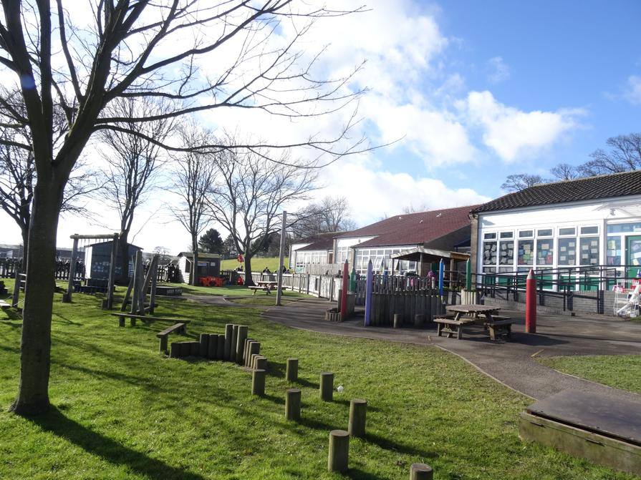
Airy Hill Primary School is situated on Waterstead Lane, just off the A171, within walking distance of the town centre.
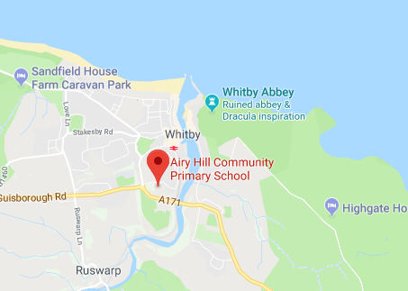

School staffing and structure

Airy Hill Primary School admits children into the school nursery from 2 years old or into Reception class in the September after their fourth birthday.

The school comprises 8 classes: Nursery, Reception and a class for each of the years 1-6. Children are taught and supported by qualified teachers, teaching assistants and early years practitioners.

The School Day

The school day begins at 8:45am. Children may begin to arrive at 8:35am when the school gates are unlocked but should be supervised by an adult until 8:45am when the bell is rung.

Lunch takes places from 12:00noon – 1pm daily.

School closes at 3:15pm when children should be collected promptly.

Extended School Provision: Breakfast Club
The school runs breakfast club daily from 7:50am. Breakfast club runs for an hour. There is a small charge to attend.

Breakfast options include: Choice of cereals, Toast with a choice of toppings (including hot beans or spaghetti), a drink

Places can be booked via the parent pay.

Extended School Provision: Night Owls
Night Owls runs from 3.15pm until 6pm. The Night Owls take part in many crafting activities. Pupils who stay after 4.30pm will get a snack and a drink. There is a small charge for Night Owls. This can be booked on parent pay.
Our Facebook page is frequently updated with current posts and photos of our activities.
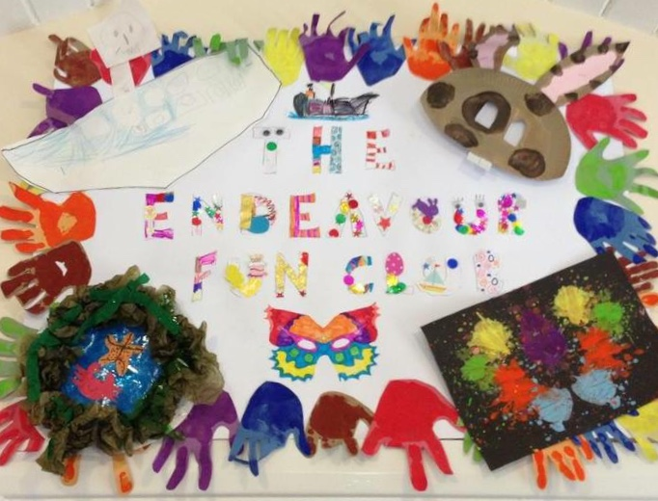

Teaching and Learning at Airy Hill Primary School

The Curriculum
Every child will succeed at Airy Hill and we pride ourselves on our exceptionally high-standards and academic achievement. To achieve this, our mornings have a focus on reading, writing and mathematics. During the afternoon sessions, our Wider Curriculum focuses on a broad curriculum with many opportunities for school trips and visits. It is our belief that pupils learn best from visiting places and actively learning in their environment.

Our Curriculum Aims for children
Our Aims were created with the whole school community. As a Rights Respecting school our curriculum is driven by the views of our pupils. These are the aims of the curriculum that our whole school community devised.

- We are resilient and tackle challenges.
- We go on overnight adventures.
- We are polite and respect others.
- We are proud of our heritage.
- We are confident and try new things.
- We are happy and friendly.
- We are artistic.
- We respect the rights of others.
- We represent the school at sports.

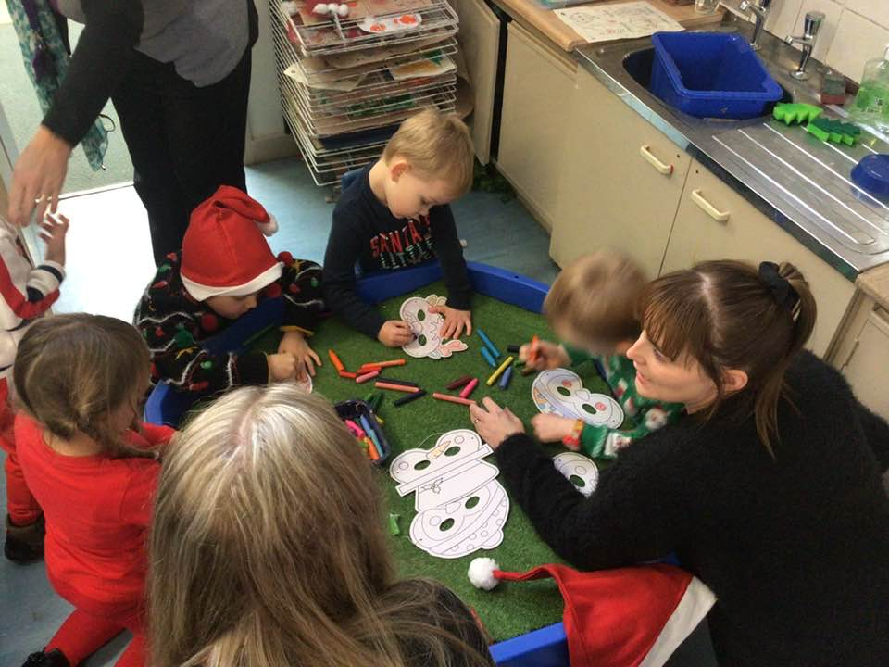
Lessons taught at Airy Hill Primary School

Lessons taught every day: Reading, Writing, Spelling & phonics
Maths, Grammar
Lessons taught over the week: Handwriting
Science
Geography, History, French, DT & RE
PE
Music
Personal, Social, Health and Citizenship Education
Lessons taught over a few weeks: Forest School

At Airy Hill we are aware of the value of giving children first hand learning experiences. Therefore, when involved in project work the children will be encouraged to make use of the local environment.

We are particularly fortunate in being close to the river, the beach, the town and the countryside. Next to the school we have a wooded area which is used for Forest Schools activities, Science and Outdoor Adventurous Activities.

Ensuring children make good progress
We are continuously assessing the progress that children make through observation, scrutiny of written work and occasional testing. Any child who is identified to be falling behind is quickly given additional teacher input and, where appropriate, intervention programmes to help them to catch up.

Special Educational Needs

All children at Airy Hill Primary School are entitled to a broad, balanced and relevant curriculum. They are encouraged to be happy and achieve the very best of which they are capable. It is our policy to identify a child’s specific needs early and involve parents in developing and carrying out a joint learning approach at home and in school.
If a child is experiencing difficulties in accessing the curriculum for whatever reason, initially the class teacher will provide a variety of learning opportunities and experiences to attempt to resolve these needs. If the child’s progress continues to cause concern then the Special Educational Needs Co-ordinator (SENCO) will be involved and with the class teacher, will provide additional or different support. Parents and children will also be involved and an Individual Provision Map will be produced setting out short term targets.

If, when the IPM is reviewed, the child has continued to make little or no progress, or continues to experience difficulties in certain areas, then, in consultation with parents, external services are invited into school. For example it could be the Learning Support Teacher for the area, a Speech Therapist, Occupational Therapist, Behaviour Support Teacher, Educational Psychologist etc. They meet the child and then offer advice to enable the class teacher and SENCO to produce a new IPM and provide further support.

Events within school
We regularly hold events within school to promote a love of learning and we invite parents to attend many of these events. Events include our Reading Café, dance shows, productions, ‘Families in School’ days and open mornings.

Sport
One of our key aims, as decided by our whole school community is to represent the school at sport. Therefore, sport plays a huge part in Airy Hill life. We have sports clubs each night and we enter all sports competitions and events in the Whitby area. Our P.E. sessions are delivered by high-quality P.E. specialists. Each child is entitled to a minimum of 2 hours of P.E. each week. Our sporting success is witnessed by the considerable number of trophies acquired by our teams.

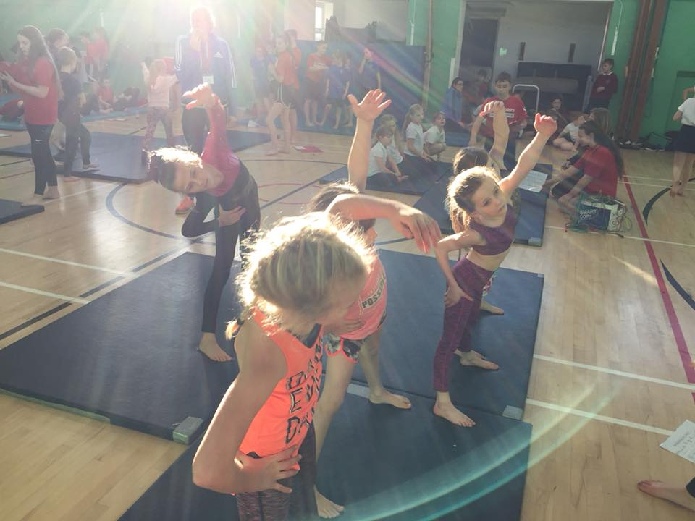

Visits & Visitors
Visits are an integral part of the Airy Hill curriculum. We aim to give our children the opportunity to experience a wide variety of visits both local and distant. Recent visits have included:
Peat Rigg Outdoor centre (Residential)
East Barnby Outdoor Centre (Residential)
London visit
Doodlepots Café, Whitby
Captain Cook Museum, Whitby
Ice-Skating, Whitby
Pantomime, Scarborough

British Values
Airy Hill Primary School is committed to serving its community. The multi-cultural, multi faith nature of the United Kingdom is recognised and celebrated and we understand our crucial role in promoting the key British Values: Mutual Respect, The Rule of Law, Tolerance of those with different Faiths and Beliefs, Individual Liberty and Democracy. Further details can be found on the school website.

Extra-Curricular
There are a number of activities held during lunchtime and after school which include football, netball, rugby, traditional dancing, gymnastics, choir, recorder, Environment team and Cyber café.

IT
We incredible IT facilities at Airy Hill. We realise that been computer and ICT literate is essential in the modern world. Due to this, we have weekly computing sessions and each child in school is given a chromebook. These are used throughout the day, ensuring your child leaves Airy Hill computer literate.
All children agree to our internet users policy and we have thorough systems in place to ensure that they do not gain access to inappropriate materials.

Homework
We encourage a partnership between parents and teacher. This is particularly evident in the way children develop their reading skill by taking books home to share with their families and practice basic skills such as times tables and spelling. Other work will be sent home when deemed appropriate.

Community links/ Charity
The school has many links to the local community and likes to support in the community in practical ways. Children regularly raise money for local charities such as the RNLI and donate food to the Whitby Food Bank. They plant flowers, care for the school environment and visit local residential homes at Christmas.

School Policy and Procedure

School Uniform
Airy Hill has a school uniform which is comfortable, easy to clean and we are very pleased that our parents support this. Most of the uniform can be purchased cheaply at local stores such as Boyes or Sainsbury’s. School jumpers and cardigans can be purchased from the school office. Alternatively, the Friends of Airy Hill, run a pre-loved uniform shop where uniform can be purchased for a voluntary contribution.
Winter and Spring term | Summer term
Grey or black skirt or trousers  White Polo Shirt  School sweat shirt or school cardigan  Black school shoes | Green or yellow summer dress or grey/black trousers/shorts  White or yellow polo shirt  School sweat shirt or school cardigan  Black school shoes

PE Kit
Indoor PE | Outdoor PE
Plain white T shirt  Black or Navy Shorts  Black Pumps | Plain white T shirt  Black or Navy Jogging Bottoms  Sweatshirt  Trainers

No jewellery on any description should be worn during the school day.

School Dinners
We are fortunate to have our own kitchen in school. School meals are provided by our cook, and are available for all pupils.
All pupils in Reception, Year 1 and Year 2 are entitled to a free school meal. Families may be eligible for free school meals and a form is available from the school office to complete. Paid meals cost £2.60 per day (£13.00 per week) and should be paid by using parent pay.

Dinners are cooked on a three-week rolling menu, a copy of which is sent home in advance of each term so that meals can be chosen. Each day there is the option of a hot dinner, a sandwich or a jacket potato with a variety of fillings/toppings. Vegetarian and special medical diets are catered for. Children who do not have a school meal may bring a packed lunch.

Snacks
Children are allowed to bring fresh fruit or cereal bars only to school for a mid-morning snack, and this must be eaten during playtime. Toast and drinks are available from the kitchen during morning break. There is a water fountain available at all times for drinks.

Behaviour & School Rules
At Airy Hill behaviour is exemplary. As a Rights Respecting school, our pupils are taught about the feelings of others and how their actions can impact on pupils learning. We have three simple rules, Be Kind, Be Safe Be Ready. Pupils are given learning points through the day for showing good learning behaviours. At the end of the day, the learning points are put into a prize-draw and one is picked out. The winner receives a prize. Airy Award Badges, ranging from bronze-gold and the Headteacher Award badge, are awarded to pupils who behave well and follow all of the Airy Aims.

Admissions
Children are admitted to Nursery from their 2nd birthday, some are entitled to funding. All children become
funded the term after their 3rd birthday. We admit children into our Reception in one intake in the September of each year. We admit any child who will turn 5 during the academic year. Children are invited into school for a number of visits before starting school and a home visit can be arranged so that children can meet their new teacher in a familiar setting. Children attend school full time immediately, if you feel your child needs to start part time then please come and discuss this with us.

Attendance
The school’s attendance target is 96% which reflects our belief that good school attendance is vital in order for children to reach their full potential. We ask parents and carers to work with children from the day their children begin school to promote a pattern of good school attendance. If your child’s attendance falls below 90%, they are considered a ‘persistent absentee’ and you will be asked to attend a meeting in school to discuss this. There are many ways that school can help to support your child’s good attendance at school and we encourage families to work closely with us for the best outcomes for your child.

Attendance: Notifying school when a child is ill
If your child is absent from school for any reason, it is extremely important that you let the school know, as the reason for absence must be recorded in the register. A phone call to school before 8.50am should be made to inform the school of absence (this should be done on every day the child is absent). If no explanation has been received the school office will try to contact the parent/carer and in some cases a member of staff may make a visit to the family home to ensure the child’s safety.

Attendance: Leave of absence in term time
Acting under new Government guidance, the Governors of schools in the Whitby Area Schools Partnership will not grant leave of absence during term time, unless there are extreme extenuating circumstances.

We appreciate the difficulty some parents/carers may have in taking holidays in the summer break due to the seasonal nature of work in the area and the impact this may have on families. However, holidays are not considered to be an extreme extenuating circumstance and, therefore, I hope you will accept that requests for holidays during term time will not be authorised and will appear on a student’s attendance record as an ‘unauthorised absence.’

Any period of unauthorised absence of 5 days (10 sessions) or more may lead to you being issued with a Penalty Notice from the Local Authority.

Punctuality
The register is called at 8.50 am. The register is an important legal document which must be marked accurately and on time. Please make sure your child is in class by 8:45am so s/he is present when the register is called. Punctuality is important both at school and later in life.

Home/ School Communication
We believe that the relationship between home and school is essential. We put this into practice daily by ensuring that members of staff are always available on the school playground at the beginning and end of the school day.

In the Autumn and Spring Terms there will be a formal opportunity for parents to come into school and discuss their child’s progress with the class teacher. These visits take place in the afternoon or evening and are based on an appointment system. The Headteacher is also available on these occasions to answer any questions which may arise. We operate an open-door policy in school, and class teachers are available at the end of the day for any queries.

Friends of Airy Hill
Friends of Airy Hill is the school’s very active Parent Teacher Association. Recent events organised by the group have included ‘Valentines Masquerade Disco’, Breakfast with Santa, the Christmas Fair and Easter Bingo. The group are always on the look out for more volunteers and it’s a great way for new families to get to know the school community.

Safeguarding
All school staff and volunteers have a statutory obligation to report any possible indicators of child abuse to the Designated Senior Lead for Child Protection who will then take appropriate action to keep the child safe. At Airy Hill, the Designated Senior Lead is the Headteacher, Mr Butters and the Deputy Leads are: Miss H Worthington and Mrs K Payne.

Administering Medication
School staff can only administer medication that has been prescribed by a doctor and is required four or more times per day. If it is essential that your child receives prescribed medication during the school day, please bring it in the original container to the main office. It must be clearly marked with the child's name and the dosage.

Site Security
In the interests of security we must insist that all visitors (including parents) please use the main entrance and report to the office on entering the building. The school car park is for staff only.

Equal Opportunities
It is our policy that whilst at Airy Hill School, children will be given the opportunity to develop their full potential regardless of ability, gender, class, religion, nationality and race. We hope that this policy will be seen to be reflected in the happy, caring atmosphere created within the school.

Collective Worship
Assemblies are non-denominational in character, we foster a caring family atmosphere within the school based upon Christian morality and ethics. In assemblies, stories from real life are used to give up-to-date examples of Christian principles. We aim to make children aware of how to treat each other whilst going about their everyday business in and out of school. Assemblies include singing, discussion, reflection and occasional hymns/ prayers. Father Michael from St. Hilda’s Parish, visits the school each term.

Charging
Under the terms of the Education Reform Act 1988, the school is not allowed to make a charge for visits or extra activities in school time such as day excursions. However, we are allowed to ask for voluntary contributions which may constitute the whole or part of the total cost of any activity.
The Governors and the staff are in agreement that if we are to continue to involve children in extra school activities and take them to places of interest, the Voluntary Contribution Scheme will enable us to do so.
No child will be excluded from an activity if his or her parent does not make the suggested contribution. However, if insufficient voluntary contributions are received, then regrettably the activity will not go ahead. Our visits are well planned and enjoyed by both children, parents and staff alike. They are of both educational and social benefit and hope that they will continue to be part of our school year.

Complaints
Wherever possible I shall be available to discuss any concerns you may have regarding your child’s progress and wellbeing at school. An appointment is not vital; however, if you phone or write I will make sure you are seen immediately. Similarly if your child has a problem, I hope either my staff or I will be able to meet with you to discuss the matter. You can also email me at via the school email address: admin.airyhill@yeat.co.uk.

We want the school to provide a happy, stimulating family atmosphere in which everyone can experience success. As in any family there may be times when misunderstandings or disagreements occur. Should this happen, please do not hesitate to contact the class teacher or myself and hopefully any problems can be resolved in an amicable and satisfactory manner.

If a solution cannot be found, we have a school complaints procedure which is available on the school website.

