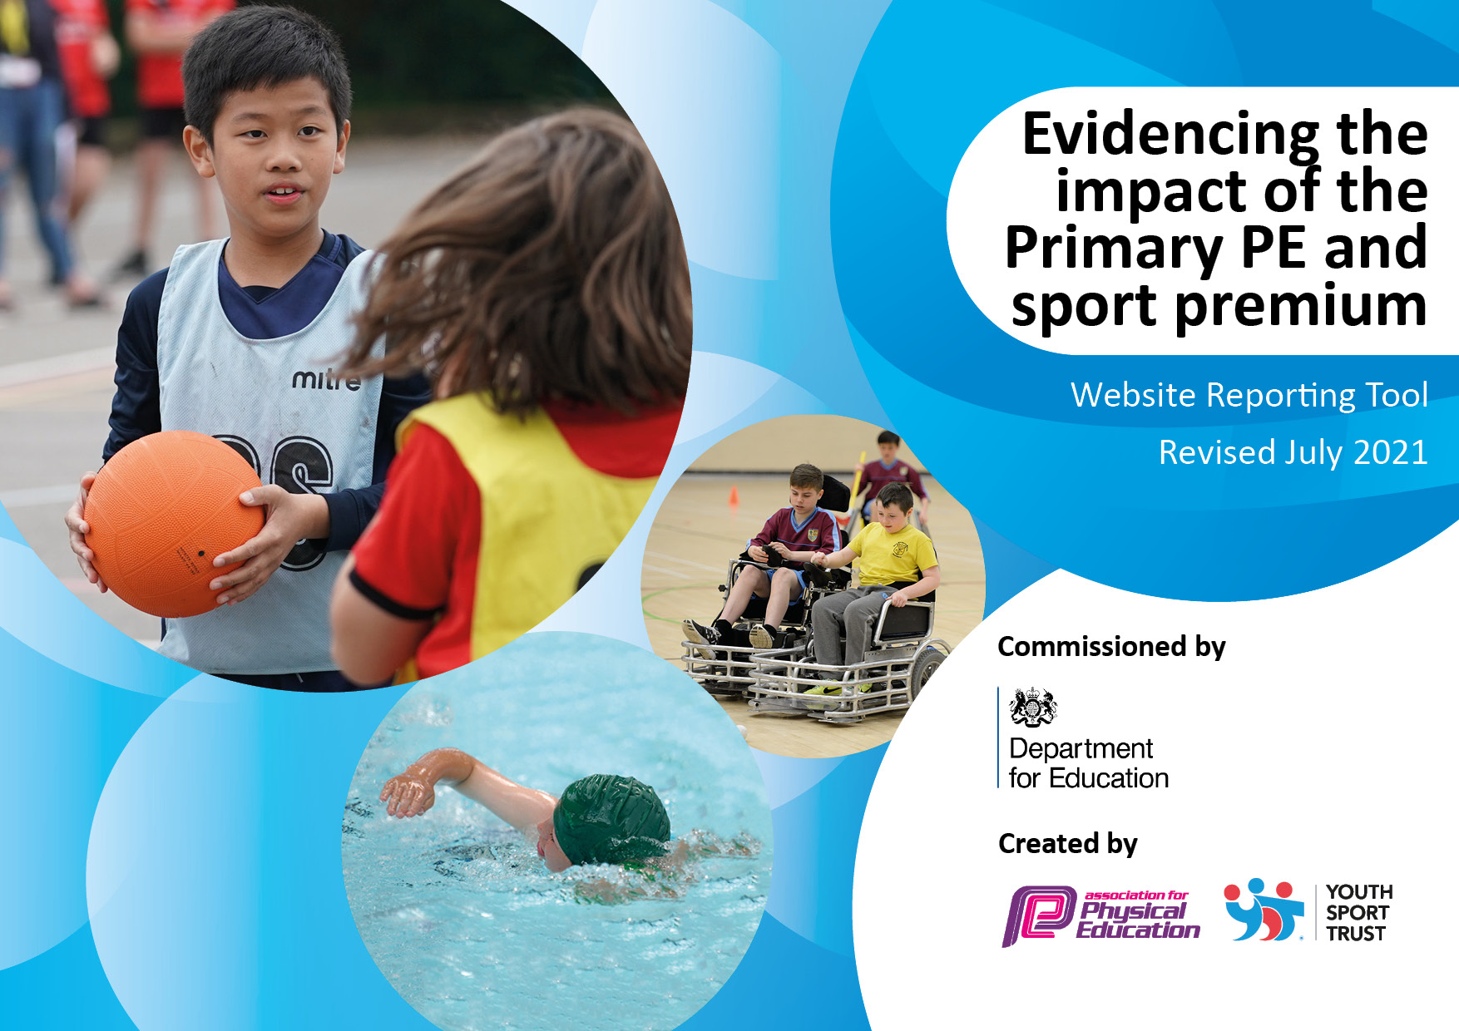
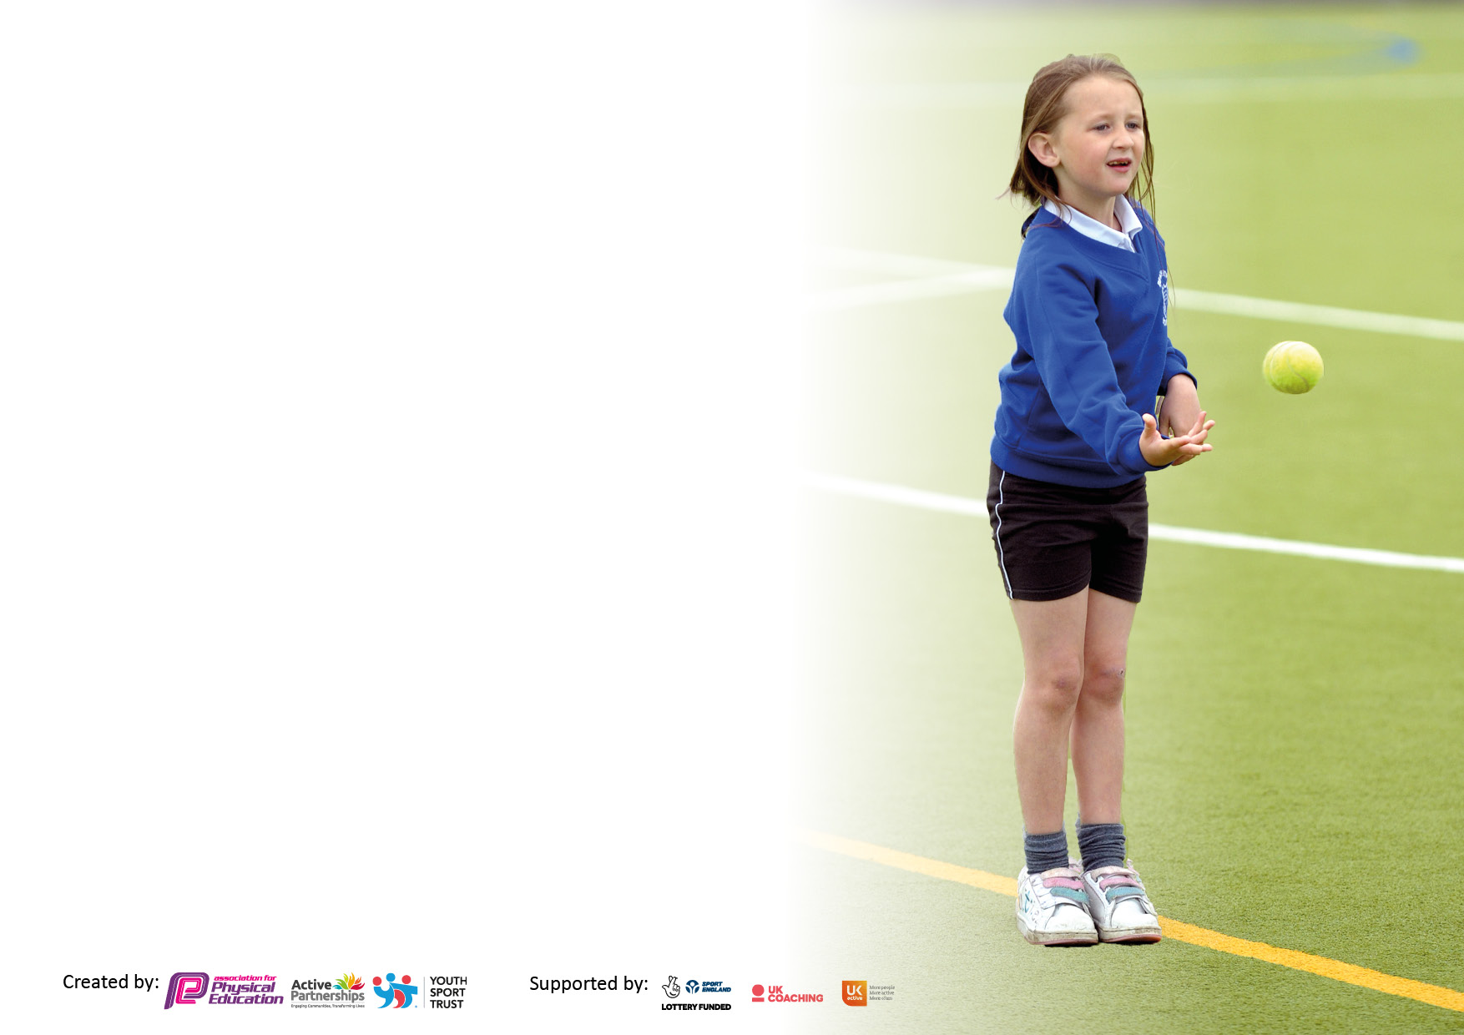

It is important that your grant is used effectively and based on school need. The Education Inspection Framework makes clear there will be a focus on ‘whether leaders and those responsible for governors all understand their respective roles and perform these in a way that enhances the effectiveness of the school’.

Under the Quality of Education Ofsted inspectors consider:
Intent - Curriculum design, coverage and appropriateness
Implementation - Curriculum delivery, Teaching (pedagogy) and Assessment
Impact - Attainment and progress

To assist schools with common transferable language this template has been developed to utilise the same three headings which should make your plans easily transferable between working documents.

Schools must use the funding to make additional and sustainable improvements to the quality of Physical Education, School Sport and Physical Activity (PESSPA) they offer. This means that you should use the Primary PE and sport premium to:

- Develop or add to the PESSPA activities that your school already offer
- Build capacity and capability within the school to ensure that improvements made now will benefit pupils joining the school in future years
- The Primary PE and sport premium should not be used to fund capital spend projects; the school’s budget should fund these.

Pleasevisitgov.ukfortherevisedDfEguidanceincludingthe5keyindicatorsacrosswhichschoolsshoulddemonstrate animprovement.Thisdocumentwillhelpyoutoreviewyourprovisionandtoreportyourspend.DfEencouragesschools to use this template as an effective way of meeting the reporting requirements of the Primary PE and sport premium.

We recommend you start by reflecting on the impact of current provision and reviewing the previous spend.

Schools are required to publish details of how they spend this funding, including any under-spend from 2021/2022, as well as on the impact it has on pupils’ PE and sport participation and attainment. All funding must be spent by 31st July 2023.

We recommend regularly updating the table and publishing it on your website throughout the year. This evidences your ongoing self-evaluation of how you are using the funding to secure maximum, sustainable impact. Final copy must be posted on your website by the end of the academic year and no later than the 31st July 2021. To see an example of how to complete the table please click HERE.
Created by: Supported by:

Details with regard to funding
Sports funding is £16,000 & £10 per pupil
£16,000 + (174 x £10) = £17, 740

Total amount carried over from 2022/23 | £0
Total amount allocated for 2022/23 | £17,520
How much (if any) do you intend to carry over from this total fund into 2022/23? | £0
Total amount allocated for 2023/24 | £17, 710
Total amount of funding for 2022/23. To be spent and reported on by 31st July 2023. | £24,000
Swimming Data
Please report on your Swimming Data below.

Meeting national curriculum requirements for swimming and water safety.

N.B. Complete this section to your best ability. For example you might have practised safe self-rescue techniques on dry land which you can then transfer to the pool when school swimming restarts.
Due to exceptional circumstances priority should be given to ensuring that pupils can perform safe self rescue even if they do not fully meet the first two requirements of the NC programme of study
What percentage of your current Year 6 cohort swim competently, confidently and proficiently over a distance of at least 25 metres?
N.B. Even though your pupils may swim in another year please report on their attainment on leaving primary school at the end of the summer term 2022.
Please see note above
What percentage of your current Year 6 cohort use a range of strokes effectively [for example, front crawl, backstroke and breaststroke]?
Please see note above
What percentage of your current Year 6 cohort perform safe self-rescue in different water-based situations?
Schools can choose to use the Primary PE and sport premium to provide additional provision for swimming but this must be for activity over and above the national curriculum requirements. Have you used it in this way? | Yes

Action Plan and Budget Tracking
Capture your intended annual spend against the 5 key indicators. Clarify the success criteria and evidence of impact that you intend to measure to evaluate for pupils today and for the future.

Academic Year: 2023/24 | Total fund allocated: £17,710 | Date Updated: October 2023
Key indicator 1: The engagement of all pupils in regular physical activity – Chief Medical Officers guidelines recommend that primary school pupils undertake at least 30 minutes of physical activity a day in school |  |  |  | Percentage of total allocation:
 |  |  |  | 25%
Intent | Implementation |  | Impact
Your school focus should be clear what you want the pupils to know and be able to do and about  what they need to learn and to  consolidate through practice: | Make sure your actions to achieve are linked to your intentions: | Funding allocated: £6000 | Evidence of impact: what do pupils now know and what can they now do? What has changed?: | Sustainability and suggested next steps:
Motivate all children, with a particular focus on the least active, to participate in a minimum of 30 minutes physical activity every day. Provide structures to encourage children to increase and track their activity out of school. | - Increase active play through play leaders at lunchtimes (150 pupils)  - Continue and develop the 30:30 challenge, with a focus on least active (181 pupils but targeted at least active 10%)  - All children to experience at least half a term of Forest School per year (181 pupils)  - All children to experience swimming for a minimum of half a term. (181 pupils) | HLTA time  Subject Leader Release time  Forest school leader and training time  Resources  Additional swimming costs.
Key indicator 2: The profile of PESSPA being raised across the school as a tool for whole school improvement |  |  |  | Percentage of total allocation:
 |  |  |  | 15%
Intent | Implementation |  | Impact
Your school focus should be clear what you want the pupils to know and be able to do and about  what they need to learn and to  consolidate through practice: | Make sure your actions to achieve are linked to your intentions: | Funding allocated:  £3500 | Evidence of impact: what do pupils now know and what can they now do? What has changed?: | Sustainability and suggested next steps:
Children value the benefits of a healthy and active lifestyle. They enjoy sports activities and have opportunities to take part at a range of levels. | - Continue and develop the 30:30 challenge  - Use Facebook updates and feature in newsletter to share children’s participation and achievements  - Weekly Sports Awards are presented in assembly (parents invited to attend)  - Inter-sports competitions half-termly to raise profile of developing skills.  - Creation of house teams for pupils to compete regularly against peers.  - Yearly, YEAT Olympics with the opportunity for all pupils to compete against other Trust schools.  - All competitions and festivals are attended. | HLTA time  Subject leader time  Resources  Sports Partnership membership costs.  End of year award badges for the winning team colour.

Key indicator 3: Increased confidence, knowledge and skills of all staff in teaching PE and sport |  |  |  | Percentage of total allocation:
 |  |  |  | 34%
Intent | Implementation |  | Impact
Your school focus should be clear | Make sure your actions to | Funding | Evidence of impact: what do | Sustainability and suggested
what you want the pupils to know | achieve are linked to your | allocated:  £8,000 | pupils now know and what | next steps:
and be able to do and about | intentions: |  | can they now do? What has
what they need to learn and to |  |  | changed?:
consolidate through practice:
All children receive two hours of quality PE teaching each week. In addition to specialist coaches, staff have access to regular CPD and supportive teaching materials. | - Maintain subscription to the PE Hub to support teaching and assessment  - Specialist PE coach used to teach across all year groups and model best practice to teachers.  - At least three CPD sessions per year for all teachers  - Specialist PE HLTA time to deliver high quality lessons  - Specialist dance teacher to deliver lessons to each class over the course of the year | PE Hub  Coach/ Dance teacher costs  HLTA time
Key indicator 4: Broader experience of a range of sports and activities offered to all pupils |  |  |  | Percentage of total allocation:
 |  |  |  | 21%
Intent | Implementation |  | Impact
Your school focus should be clear | Make sure your actions to | Funding | Evidence of impact: what do | Sustainability and suggested
what you want the pupils to know | achieve are linked to your | allocated: | pupils now know and what | next steps:
and be able to do and about | intentions: |  | can they now do? What has
what they need to learn and to |  | £5000 | changed?:
consolidate through practice:
Children have the opportunity to take part in a wide range of sports and activities within the school day as well as through extra-curricular opportunities. | - Continue to subscribe to the local PE Sports Partnership  - Subside Outdoor and Adventurous activities such as Y5 ‘Survival Day’  - Continue to swim in all year groups (181 pupils)  - Arrange experience days such as skipping and ice skating (150 children)  - Fund or subsidise a range of after school activities such as football, sport stacking, yoga, etc. (90 children) | Sports partnership  Visit costs  Additional swimming costs  Experience days  After school clubs

Key indicator 5: Increased participation in competitive sport |  |  |  | Percentage of total allocation:
 |  |  |  | 5%
Intent | Implementation |  | Impact
Your school focus should be clear | Make sure your actions to | Funding | Evidence of impact: what do | Sustainability and suggested
what you want the pupils to know | achieve are linked to your | allocated: | pupils now know and what | next steps:
and be able to do and about | intentions: |  | can they now do? What has
what they need to learn and to |  | £1000 | changed?:
consolidate through practice:
Provide children with the confidence and opportunity to compete in sports at different levels. | - Continue to subscribe to the local PE Sports Partnership  - Arrange / take part in a number of Inter-school competitions  - Introduce a termly school Sports Day  - Create a house team model across school so pupils compete against their peers each half-term.  - Tailor after school clubs to upcoming sports competitions so pupils are confident in that area of P.E. and can compete confidently against others. | Sports partnership (costed above)  Additional HLTA time to facilitate competitive sport

Signed off by
Head Teacher: | Sam Butters
Date: | 26.9.23
Subject Leader: | Sam Butters/ Mandie Frankland
Date: | 26.9.23
Governor: | Deborah Hall
Date:

